**Kennedy Park National School**

**Newsletter – October 2017**

**---------------------------------------------------------**

**H.S.C.L**

There will be a free Hallowe’en pumpkin carving/coffee morning in the parents’ room in school on Wednesday 25th October at 9.15 am. All parents/guardians are welcome to attend. If you would like to come along please ring the school secretary, 053-9123331 (We need to know in advance to buy enough pumpkins!)`



**Book Club**

We are forming a book club for parents in the school. The book club will meet on the first Wednesday of the month at 1.10 pm in the parents’ room. The first meeting will take place on Wednesday 8th November. Please phone the office to book in.



**Garda Vetting**

Each year we run special projects in every class and we need a helping hand from parents/guardians. These are very worthwhile projects and parents who helped in the past really enjoyed themselves. The children love to see their parents coming to class. All adults who work with children have to be garda vetted.

This is a straightforward process involving filling out a form and returning it to school, bringing 2 forms of identification with you e.g. driver’s license/passport.

The programmes start in November in Senior Infants, 2nd and 3rd classes, so please fill in a form as soon as possible if you would like to take part.

**Note:** Parents previously vetted through the school **do not** have to be re-vetted.

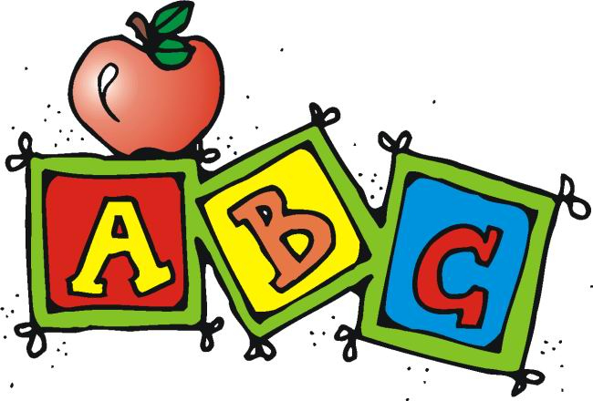

**Dates for your Diary**

Kennedy Park N.S. will close for Hallowe’en midterm break on **Friday 27th October** and

re-open again on **Monday 6th November**.

**Curriculum Inservice Day**

The Department of Education and Science are currently rolling out a new primary language curriculum. All our teaching staff will receive inservice on this integrated language curriculum on **Friday 20th October**. School will close on this date to facilitate the training.

**Parent/Teacher meetings**

Parent/Teacher meetings for all classes will take place on Tuesday 21st November and Wednesday 22nd. To help teachers co-ordinate meetings for siblings, school will remain open until 5.30pm on these days.

**Parents’ Council**

The Parents’ Council would like to invite new members to join their committee. Their next meeting is on the 18th October at 7.00 pm.

We invite all parents to attend.

**Sing Out Loud!**

Sing Out Loud is back for its annual concert in the National Opera House, Wexford. Pupils from our 5th and 6th classes will be on stage on Sunday 19th November at 7.30 pm. We look forward to a great evening of entertainment and wish all of our choir from Kennedy Park the very best on the night.

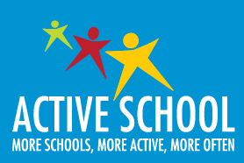

**Active Flag**

Congratulations to our whole school community on attaining **The National Active Flag** and the **HSE Health Promoting Flag.** This was a mammoth achievement in just one academic year.

Huge thanks to Ms. Sylvia Wickham and Ms. Nicola Gregg for leading us all in this initiative. We look forward to a date for the raising of our new flags.