Healthy Lunch Policy
Aim:
The aim of this policy is to ensure children eat a healthy, well-balanced lunch, thus promoting a healthy lifestyle. Encouraging healthy eating patterns educates children for later life.
Guidelines:
Children are encouraged to bring a healthy lunch to school. To promote a healthy lifestyle, children are not allowed to bring sweets, bars, chocolate or biscuits to school. However, Friday is Treat Day, when they can bring one small treat i.e. funsize bar, funsize packet of sweets etc.
We encourage children to follow the advice from
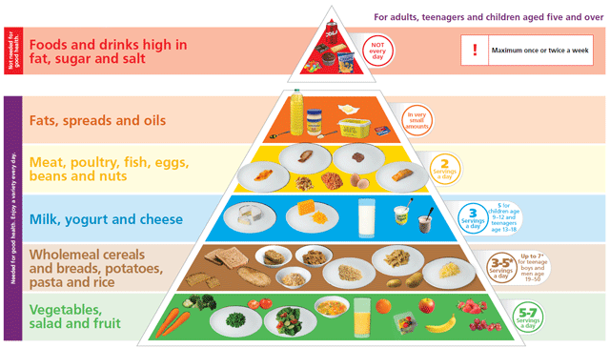

The following are not allowed: chewing gum, crisps, fizzy drinks, biscuits, sweets and chocolate (except on Fridays)

Roles and Responsibilities:
Role of Parents:
- Provide a healthy well-balanced lunch for children
- Encourage healthy eating
- Inform the school of any child’s special dietary needs
- To implement school policy by not allowing their children to bring unhealthy foods to school
Role of Children:
- To eat their lunch
- To bring home any uneaten lunch and packaging
- To help make their lunches and remind parents of the Healthy Lunch Policy.
Role of School:
- To promote and encourage healthy eating.
- If children bring treats into school they will not be allowed to eat them (except on a Friday).
- Children will be encouraged to drink water throughout the day.
Implementation:
This policy will be implemented from ……………
As part of the Social Personal and Health Education curriculum, healthy eating will be discussed with the children regularly by staff.
Teachers will continue to give children a sweet treat on occasions in recognition of work done, improvements in work or behaviour and in an effort to promote positive behaviour. Sweet treats used prudently by teachers will not interfere with the health of the children.
Fresh Today/Free Lunches:
If your child avails of the Free Lunch we would recommend that he/she does not bring any extra food to school.

